3.4 I can set up and use permissions to filter information

On my mobile phone I use Microsoft One Drive to back up my photos and any important documents that I would like to keep for further reference. When using the internet to open files such a pdf documents I can also use the application to open and save the PDF.

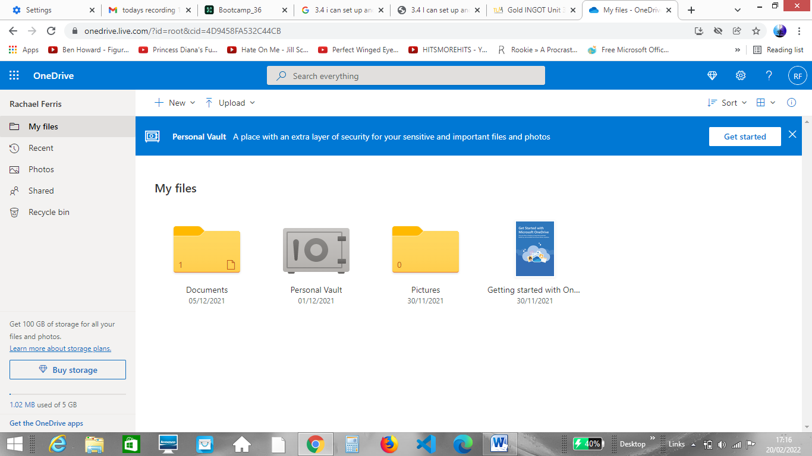

My One Drive account is set to private however if I want to share documents or pictures I can do so by opening the document I want to share and selecting the share radio button on the top right of the page;

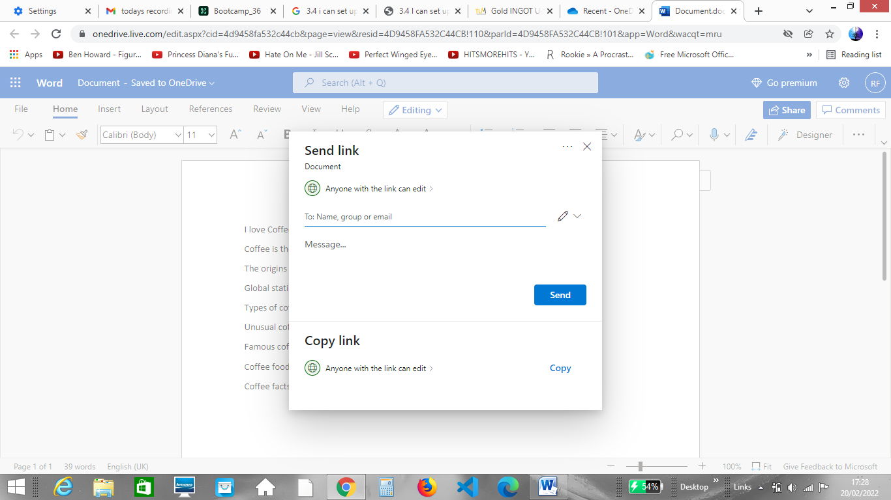

The share button allows me to send a link to individuals or groups as shown above. It is important to note that if you give permissions to anyone that has the link people that you don’t want to have access to your one drive could gain access if the link if forwarded to them. In the example above the *‘Anyone with the link can edit’* option is selected. There are additional permissions you can select to safeguard against this;

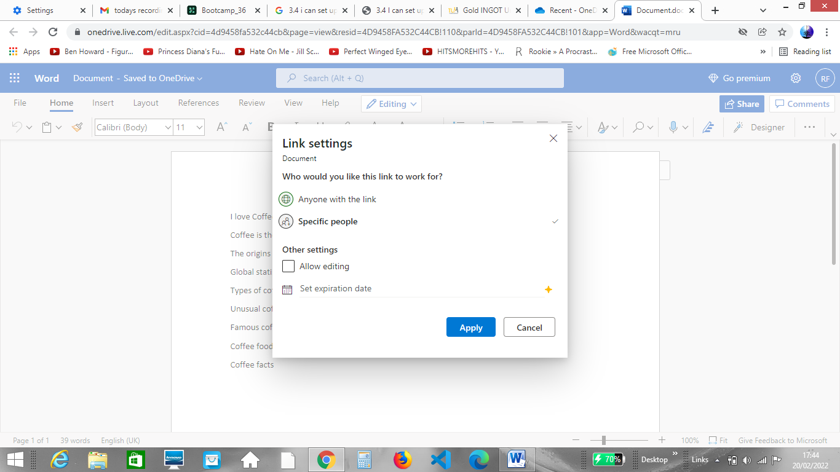

In the example above you can see that I have selected for the link to be accessed by specific people only. I have also removed the ability to edit the document meaning that only I can make changes to the document.